1.Extracted Data
1.1 Extracted Data for RQ1
Source artifact | Target artifact | Technology | Year | Baseline | Item | Ref.
Issue | Problem report | DeepMatcher | 2021 | - | S1 | [18]
Issue | Pull-request | ML models | 2023 | - | S14 | [28]
Issue | Revision | LCDTrace classifier | 2022 | - | S2 | [19]
Issue | Revision | LCDTrace tool | 2023 | - | S5 | [22]
Issue | Test case | improvement techniques | 2020 | - | S3 | [20]
Issue | Test case | use of system features | 2021 | - | S7 | [23]
Issue | Commit | Random forest classifier | 2018 | - | S6 | [6]
Issue | Commit | DeepLink | 2019 | PULink | S12 | [26]
Issue | Commit | DeepLink | 2019 | FRLink | S13 | [27]
Issue | Commit | GVSM based method | 2020 | VSM,LSI,LDA,GVSM | S8 | [24]
Issue | Commit | T-Bert | 2021 | VSM,LDA,LSI,TNN-LSTM,TNN-BiGRU | S9 | [1]
Issue | Commit | Hybrid-Linker | 2021 | DeepLink,FRlink | S10 | [25]
Issue | Commit | MT-BERT | 2022 | VSM,LSI,LDA,GVSM | S4 | [21]
Issue | Commit | EALink | 2023 | T-BERT,DeepLink,VSM | S15 | [29]
Issue | Commit | BTLink | 2023 | FRLink,DeepLink,hybrid-linker | S11 | [7]
Issue | Commit | SPLINT | 2022 | VSM,Random forest classifier | S16 | [30]

1.2 Extracted Data for RQ2
Research method | Context | Subjects | Scale | Primary studies
Case study | Academic | Student | Down-scale example | S3,S7
Case study | Academic | Practitioner | Industrial | S2
Case study | Academic | Researcher | Down-scale example | S14
Case study | Industry | Practitioner | Industrial | S5
Experiment | Academic | Student | Industrial | S1,S10,S11,S12,S13,S15,S16
Experiment | Academic | Researcher | Industrial | S6
Experiment | Industry | Student | Industrial | S4,S8,S9

1.3 Extracted Data for RQ3
Research method | Context | Context described | Study design discussed | Validity discussed | Primary studies | Fre.
Case study | Industry | Strong | Medium | Strong | S5 | 1
Case study | Academic | Weak | Medium | Strong | S2,S14 | 2
Case study | Academic | Medium | Medium | Medium | S3 | 1
Case study | Academic | Weak | Strong | Strong | S7 | 1
Experiment | Industry | Strong | Strong | Strong | S4,S9 | 2
Experiment | Industry | Strong | Medium | Medium | S8 | 1
Experiment | Academic | Medium | Medium | Medium | S6 | 1
Experiment | Academic | Medium | Strong | Medium | S1,S10,S11,S15 | 4
Experiment | Academic | Medium | Medium | Medium | S12 | 1
Experiment | Academic | Strong | Strong | Medium | S13,S16 | 2

Dataset Name | Source Artifacts | Target Artifacts | True Link | Source Link | Freq. | Primary study
Firefox | issue(29941) | review(5706) | 3314 | https://zenodo.org/record/2650511 | 3 | [s1]  [s3] [s7]
Firefox | Issue(93) | Test case(195) | Unclear | https://zenodo.org/record/2650511 | 3 | [s1]  [s3] [s7]
VLC | issue(553) | review(5026) | 2988 | None | 1 | [s1]
Signal | Issue(7768) | Review(10000) | 2583 | None | 1 | [s1]
NextCloud | Issue(2462) | Review(774) | 774 | None | 1 | [s1]
Service | Issue(173) | Revision(2930) | 1495 | https://github.com/RELabUU/LCDTrace | 2 | [s2] [s5]
Data | Issue(58) | Revision(818) | 582 | https://github.com/RELabUU/LCDTrace | 2 | [s2] [s5]
Store | Issue(634) | Revision(713) | 205 | https://github.com/RELabUU/LCDTrace | 2 | [s2] [s5]
Company | Issue(29) | Revision(626) | 473 | https://github.com/RELabUU/LCDTrace | 1 | [s5]
Control_1 | Issue(111) | Revision(1629) | 1144 | https://github.com/RELabUU/LCDTrace | 1 | [s5]
Control_2 | Issue(116) | Revision(768) | 493 | https://github.com/RELabUU/LCDTrace | 1 | [s5]
Control_3 | Issue(99) | Revision(498) | 353 | https://github.com/RELabUU/LCDTrace | 1 | [s5]
Learn_1 | Issue(278) | Revision(1239) | 1028 | https://github.com/RELabUU/LCDTrace | 1 | [s5]
Learn_2 | Issue(168) | Revision(303) | 198 | https://github.com/RELabUU/LCDTrace | 1 | [s5]
Portfolio | Issue(97) | Revision(1056) | 802 | https://github.com/RELabUU/LCDTrace | 1 | [s5]
PI-Link | Issue(34732) | Request(50369) | 50369 | https://www.kaggle.com/datasets/zakareaalshara/android-closed-issues-20110101-20210101-clean | 1 | [s14]
Arthas | Issue(122) | Commit(167) | 167 | https://doi.org/10.5281/zenodo.3713256 | 2 | [s4] [s8]
bk-cmdb | Issue(895) | Commit(1178) | 1179 | https://doi.org/10.5281/zenodo.3713256 | 2 | [s4] [s8]
Canal | Issue(232) | Commit(273) | 273 | https://doi.org/10.5281/zenodo.3713256 | 2 | [s4] [s8]
Druid | Issue(1092) | Commit(1161) | 1161 | https://doi.org/10.5281/zenodo.3713256 | 2 | [s4] [s8]
Emmagee | Issue(31) | Commit(32) | 32 | https://doi.org/10.5281/zenodo.3713256 | 2 | [s4] [s8]
Nacos | Issue(132) | Commit(161) | 161 | https://doi.org/10.5281/zenodo.3713256 | 2 | [s4] [s8]
NCNN | Issue(97) | Commit(99) | 99 | https://doi.org/10.5281/zenodo.3713256 | 2 | [s4] [s8]
Pegasus | Issue(160) | Commit(160) | 160 | https://doi.org/10.5281/zenodo.3713256 | 2 | [s4] [s8]
QMUI_Android(QMA) | Issue(70) | Commit(71) | 71 | https://doi.org/10.5281/zenodo.3713256 | 2 | [s4] [s8]
QMUI_IOS(QMI) | Issue(32) | Commit(35) | 35 | https://doi.org/10.5281/zenodo.3713256 | 2 | [s4] [s8]
Rax | Issue(560) | Commit(571) | 571 | https://doi.org/10.5281/zenodo.3713256 | 2 | [s4] [s8]
San | Issue(186) | Commit(275) | 275 | https://doi.org/10.5281/zenodo.3713256 | 2 | [s4] [s8]
Weui | Issue(154) | Commit(159) | 159 | https://doi.org/10.5281/zenodo.3713256 | 2 | [s4] [s8]
xLua | Issue(52) | Commit(52) | 52 | https://doi.org/10.5281/zenodo.3713256 | 2 | [s4] [s8]
Konlpy | Issue(32) | Commit(33) | 33 | https://doi.org/10.5281/zenodo.3713256 | 2 | [s4] [s8]
Cica | Issue(25) | Commit(27) | 27 | https://doi.org/10.5281/zenodo.3713256 | 2 | [s4] [s8]
Aws-berline | Issue(74) | Commit(74) | 74 | https://doi.org/10.5281/zenodo.3713256 | 2 | [s4] [s8]
Pgcli | Issue(522) | Commit(531) | 530 | https://zenodo.org/record/4511291#.YB3tjyj0mbg | 1 | [s9]
Flask | Issue(739) | Commit(752) | 753 | https://zenodo.org/record/4511291#.YB3tjyj0mbg | 1 | [s9]
Keras | Issue(550) | Commit(550) | 551 | https://zenodo.org/record/4511291#.YB3tjyj0mbg | 2 | [s9]
Keras | Issue(717) | Commit(719) | 725 | https://github.com/glnmzx888/BTLink | 2 | [s11]
Keycloak | Issue(5166) | Commit(10932) | 4157 | none | 1 | [s13]
Checkstyle | Issue(5753) | Commit(7904) | 2749 | none | 1 | [s13]
Pentaho Kettle | Issue(5286) | Commit(20210) | 3328 | none | 1 | [s13]
GoCD | Issue(4673) | Commit(7053) | 4551 | none | 1 | [s13]
fabric8 | Issue(7042) | Commit(13495) | 4611 | none | 1 | [s13]
Closure Compiler | Issue(1253) | Commit(12763) | 1197 | none | 1 | [s13]
Flink | Issue(5893) | Commit(14001) | 3610 | none | 2 | [s13]
Flink | Issue(15655) | Commit(26517) | 14472 | https://github.com/MalihehIzadi/hybrid-linker | 2 | [s10]
gRPC | Issue(3919) | Commit(2880) | 2458 | none |  | [s13]
Beam | Issue(5223) | Commit(13526) | 5178 | https://github.com/MalihehIzadi/hybrid-linker | 3 | [s13]  [s10]  [s11]
Beam | Issue(9133) | Commit(28824) | 5750 | https://github.com/MalihehIzadi/hybrid-linker | 3 | [s13]  [s10]  [s11]
Beam | Issue(7545) | Commit(35409) | 8323 | https://github.com/MalihehIzadi/hybrid-linker | 3 | [s13]  [s10]  [s11]
CreateDB | Issue(7196) | Commit(8708) | 4420 | none | 1 | [s13]
Ambari | Issue(25162) | Commit(38872) | 35597 | https://github.com/MalihehIzadi/hybrid-linker | 2 | [s15]  S[10]
Ambari | Issue(25162) | Commit(38872) | 35589 | https://github.com/MalihehIzadi/hybrid-linker | 2 | [s15]  S[10]
Calcite | Issue(3740) | Commit(6934) | 3058 | https://github.com/MalihehIzadi/hybrid-linker | 2 | [s15] [s10]
Groovy | Issue(9118) | Commit(30633) | 8851 | https://github.com/MalihehIzadi/hybrid-linker | 4 | [s15]  [s10]  [s6]  [s16]
Groovy | Issue(9117) | Commit(30478) | 8851 | https://github.com/MalihehIzadi/hybrid-linker | 4 | [s15]  [s10]  [s6]  [s16]
Groovy | issue | commit |  | https://github.com/MalihehIzadi/hybrid-linker | 4 | [s15]  [s10]  [s6]  [s16]
Ignite | Issue(12495) | Commit(32930) | 9997 | https://github.com/MalihehIzadi/hybrid-linker | 2 | [s15] [s10]
Isis | Issue(2264) | Commit(15284) | 8486 | https://github.com/MalihehIzadi/hybrid-linker | 3 | [s15] [s10]  [s11]
Isis | Issue(2159) | Commit(18864) | 12700 | https://github.com/MalihehIzadi/hybrid-linker | 3 | [s15] [s10]  [s11]
Netbeans | Issue(3705) | Commit(19181) | 1369 | https://github.com/MalihehIzadi/hybrid-linker | 2 | [s15] [s10]
Freemarker | Issue(127) | Commit(4235) | 177 | https://github.com/MalihehIzadi/hybrid-linker | 1 | [s10]
Airflow | Issue(6511) | Commit(10196) | 5295 | https://github.com/MalihehIzadi/hybrid-linker | 1 | [s10]
Arrow | Issue(7509) | Commit(6179) | 6400 | https://github.com/MalihehIzadi/hybrid-linker | 1 | [s10]
Cassandra | Issue(15413) | Commit(31491) | 146 | https://github.com/MalihehIzadi/hybrid-linker | 1 | [s10]
Tika | Issue(2229) | Commit(945) | 3404 | https://github.com/glnmzx888/BTLink | 1 | [s11]
Tez | Issue(2689) | Commit(2884) | 2888 | https://github.com/glnmzx888/BTLink | 2 | [s11]  [s12]
Tez | Issue(2901) | Commit(2574) | 2503 | https://github.com/glnmzx888/BTLink | 2 | [s11]  [s12]
Avro | Issue(2070) | Commit(3206) | 2618 | https://github.com/glnmzx888/BTLink | 2 | [s11]
Avro | Issue(1511) | Commit(1607) | 1398 | https://github.com/glnmzx888/BTLink | 2 | [s12]
Nutch | Issue(1820) | Commit(3280) | 1821 | https://github.com/glnmzx888/BTLink | 1 | [s11]
OODT | Issue(727) | Commit(2251) | 1329 | https://github.com/glnmzx888/BTLink | 1 | [s11]
Ivy | Issue(1024) | Commit(3030) | 1179 | https://github.com/glnmzx888/BTLink | 1 | [s11]
Giragh | Issue(915) | Commit(1138) | 878 | https://github.com/glnmzx888/BTLink | 1 | [s11]
Builder | Issue(190) | Commit(4385) | 837 | https://github.com/glnmzx888/BTLink | 1 | [s11]
log4net | Issue(239) | Commit(1157) | 216 | https://github.com/glnmzx888/BTLink | 1 | [s11]
Derby | Issue | Commit |  | https://goo.gl/2NMjcF | 2 | [s6],S[16]
Drool | Issue | Commit |  | https://goo.gl/2NMjcF | 2 | [s6],S[16]
Infinispan | Issue | Commit |  | https://goo.gl/2NMjcF | 2 | [s6],S[16]
Maven | Issue | Commit |  | https://goo.gl/2NMjcF | 2 | [s6],S[16]
Pig | Issue | Commit |  | https://goo.gl/2NMjcF | 2 | [s6],S[16]
ZOOKEEPER | Issue(1594) | Commit(1719) | 1513 | none | 1 | S[12]
MAHOUT | Issue(1386) | Commit(3925) | 1921 | none | 1 | S[12]
CHUKWA | Issue(819) | Commit(847) | 718 | none | 1 | S[12]
LANG | Issue(1767) | Commit(5114) | 1178 | none | 1 | S[12]
P1 | Issue(1764) | Commit(16912) | 1305 | https://doi.org/10.5281/zenodo.7111136 | 1 | S[16]
P2 | Issue(1389) | Commit(12229) | 1111 | https://doi.org/10.5281/zenodo.7111136 | 1 | S[16]
P3 | Issue(448) | Commit(4888) | 279 | https://doi.org/10.5281/zenodo.7111136 | 1 | S[16]
P4 | Issue(856) | Commit(7271) | 770 | https://doi.org/10.5281/zenodo.7111136 | 1 | S[16]
P5 | Issue(188) | Commit(1649) | 257 | https://doi.org/10.5281/zenodo.7111136 | 1 | S[16]
P6 | Issue(337) | Commit(2903) | 544 | https://doi.org/10.5281/zenodo.7111136 | 1 | S[16]
P7 | Issue(405) | Commit(6114) | 948 | https://doi.org/10.5281/zenodo.7111136 | 1 | S[16]
P8 | Issue(192) | Commit(514) | 144 | https://doi.org/10.5281/zenodo.7111136 | 1 | S[16]
P9 | Issue(270) | Commit(2437) | 287 | https://doi.org/10.5281/zenodo.7111136 | 1 | S[16]
P10 | Issue(631) | Commit(3609) | 874 | https://doi.org/10.5281/zenodo.7111136 | 1 | S[16]

Index\ Factors | Method |  |  |  | Data |  |  | Experiment |  |  |  |  | Score |  |  | D2 | D3
Index\ Factors | Problem | Research method | Research questions | Pseudo code | Dataset partition | Dataset source | Results | Hypothesis and Prediction | Source code | Hardware specifications | Software dependencies | Experiment setup | Method  (D1) | Data | Experiment | D2 | D3
S1 | 0 | 1 | 1 | 0 | 0 | 0 | 0 | 0 | 0 | 0 | 0 | 1 | 0.5 | 0 | 0.2 | 0.25 | 0.23
S2 | 1 | 1 | 0 | 0 | 1 | 1 | 1 | 0 | 1 | 0 | 1 | 1 | 0.5 | 1 | 0.6 | 0.75 | 0.7
S3 | 0 | 1 | 1 | 0 | 0 | 1 | 1 | 0 | 1 | 0 | 0 | 0 | 0.5 | 0.66 | 0.2 | 0.58 | 0.45
S4 | 0 | 1 | 1 | 0 | 1 | 1 | 1 | 0 | 1 | 0 | 0 | 1 | 0.5 | 1 | 0.4 | 0.75 | 0.63
S5 | 0 | 1 | 1 | 0 | 1 | 1 | 1 | 0 | 1 | 0 | 0 | 1 | 0.5 | 1 | 0.4 | 0.75 | 0.63
S6 | 1 | 1 | 1 | 0 | 1 | 1 | 0 | 0 | 0 | 0 | 1 | 1 | 0.75 | 0.66 | 0.4 | 0.705 | 0.60
S7 | 0 | 1 | 1 | 0 | 0 | 1 | 1 | 1 | 1 | 0 | 0 | 1 | 0.5 | 0.66 | 0.6 | 0.58 | 0.59
S8 | 1 | 1 | 1 | 0 | 1 | 1 | 1 | 0 | 0 | 0 | 1 | 1 | 0.75 | 1 | 0.4 | 0.875 | 0.72
S9 | 1 | 1 | 1 | 0 | 1 | 1 | 1 | 1 | 1 | 1 | 0 | 1 | 0.75 | 1 | 0.8 | 0.875 | 0.85
S10 | 1 | 1 | 1 | 0 | 1 | 1 | 1 | 0 | 1 | 0 | 0 | 1 | 0.75 | 1 | 0.4 | 0.875 | 0.72
S11 | 1 | 1 | 1 | 0 | 1 | 1 | 0 | 0 | 1 | 0 | 0 | 1 | 0.75 | 0.66 | 0.4 | 0.705 | 0.60
S12 | 1 | 1 | 1 | 0 | 1 | 0 | 0 | 0 | 0 | 0 | 0 | 1 | 0.75 | 0.33 | 0.2 | 0.54 | 0.43
S13 | 1 | 1 | 1 | 0 | 1 | 0 | 0 | 0 | 0 | 0 | 0 | 1 | 0.75 | 0.33 | 0.2 | 0.54 | 0.43
S14 | 0 | 1 | 1 | 0 | 0 | 0 | 0 | 0 | 0 | 0 | 0 | 1 | 0.5 | 0 | 0.2 | 0.25 | 0.23
S15 | 1 | 1 | 1 | 0 | 1 | 1 | 1 | 0 | 1 | 1 | 0 | 1 | 0.75 | 1 | 0.6 | 0.875 | 0.78
S16 | 1 | 1 | 1 | 0 | 0 | 1 | 1 | 0 | 1 | 0 | 0 | 1 | 0.75 | 0.66 | 0.4 | 0.705 | 0.60
Sum | 10 | 16 | 15 | 0 | 12 | 12 | 10 | 2 | 10 | 2 | 3 | 15
Per | 62.5% | 100% | 93.75% | 0 | 75% | 75% | 62.5% | 12.5% | 62.5% | 12.5% | 18.75% | 93.75%

2.Search process record
Database | Number of searches | Number of repetitions in each database | Number of each database (After deleting repetitions) | Number of repetitions in all databases | Total number  (After deleting repetitions)
ACM | 509 | 11 | 488 | 532 | 482
Springer | 1809 | 0 | 1809 | 532 | 1556
Science Direct | 1785 | 677 | 1108 | 532 | 872
EI | 60 | 0 | 60 | 532 | 45
IEEE | 1319 | 4 | 1315 | 532 | 1313
Web of Science | 26 | 0 | 26 | 532 | 6
Total | 5508 | 934 | 4564 | 532 | 4274

Excute inclusion/exclusion criteria
Database | apply criteria  （ISC1-ISC3, ESC1-ESC3） | apply criteria(ISC1-ISC4, ESC1-ESC3) in title, abstract, keywords | apply criteria(ISC1-ISC4, ESC1-ESC3) in full article | Snowballing | final
ACM | 516 | 83 | 15 | 1 | 16
Springer
Science Direct
EI
IEEE
Web of Science

Search records
Digital Libraries：
Database | Website
ACM | https://dl.acm.org/
Springer | https://www.springer.com/
Science Direct | https://www.sciencedirect.com/
EI | https://www.engineeringvillage.com/
IEEE | https://ieeexplore.ieee.org/
Web of Science | https://www.webofscience.com/wos/
Search terms：
P1 | traceability recovery | I1 | issue
P2 | traceability maintenance | I2 | bug
P3 | traceability assessment
P4 | requirements traceability
P5 | requirements trace
P6 | requirements tracing
P7 | software traceability
P8 | software trace
P9 | software tracing
P10 | tracking
- ACM
 | Full Text | Abstract | Title
(I1 OR I2)  AND  (P1 OR P2 OR P3 OR P4 OR P5 OR P6 OR P7 OR P8 OR P9) | 503 | 5 | 1
Advanced search:
("issue" OR "bug") AND ("traceability recovery" OR "traceability maintenance" OR "traceability assessment" OR "requirements traceability" OR "requirements trace" OR "requirements tracing" OR "software traceability" OR "software trace" OR "software tracing")
("issue" OR "issue tracking") AND ("traceability recovery" OR "traceability maintenance" OR "traceability assessment" OR "requirements traceability" OR "requirements trace" OR "requirements tracing" OR "software traceability" OR "software trace" OR "software tracing")

("issue" OR "bug") AND ("traceability recovery" OR "traceability maintenance" OR "traceability assessment" OR "requirements traceability" OR "requirements trace" OR "requirements tracing" OR "software traceability" OR "software trace" OR "software tracing" OR "tracking")

("issue" OR "issue link") AND ("commit" OR "commit link") AND ("link recovery" OR "traceability" OR "trace" OR "tracking")

Screenshot of search process in ACM:

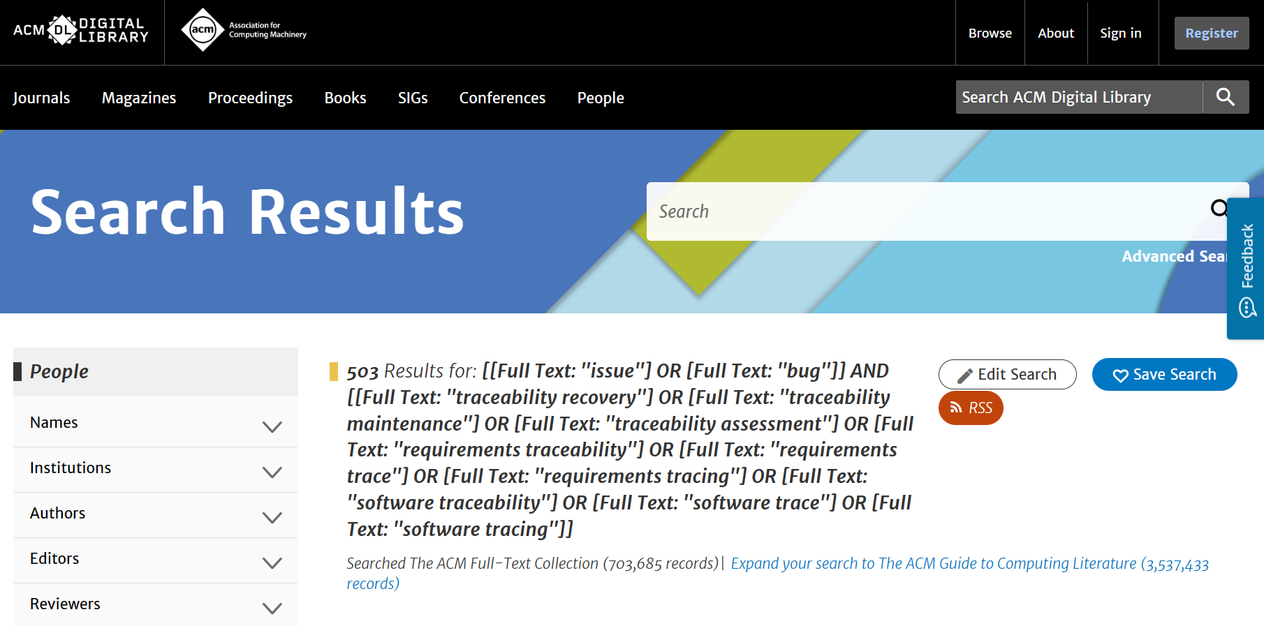


- Spinger
 | Keywords+Title+Abstract
(I1 OR I2)  AND  (P1 OR P2 OR P3 OR P4 OR P5 OR P6 OR P7 OR P8 OR P9) | 1809
Advanced search:
("issue" OR "bug") AND ("traceability recovery" OR "traceability maintenance" OR "traceability assessment" OR "requirements traceability" OR "requirements trace" OR "requirements tracing" OR "software traceability" OR "software trace" OR "software tracing")
Screenshot of search process in Springer:
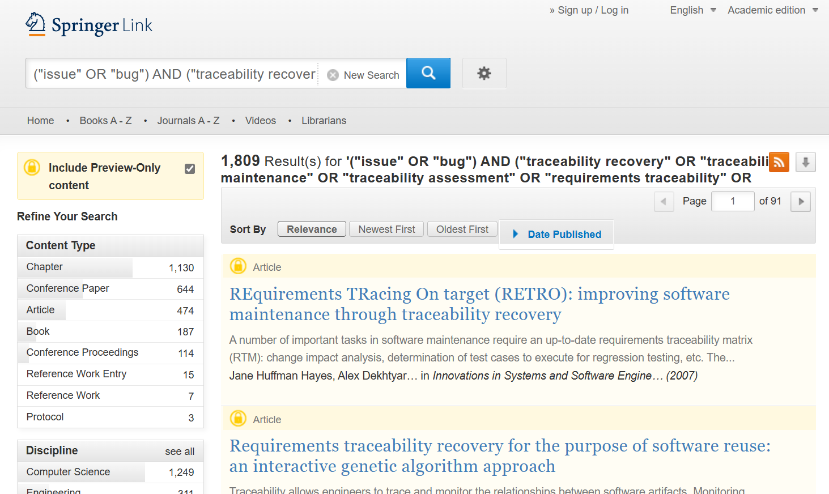
- Science Direct
 | Keywords+Title+Abstract
(I1 OR I2) AND (P1) | 161
(I1 OR I2) AND (P2) | 72
(I1 OR I2) AND (P3) | 435
(I1 OR I2) AND (P4) | 322
(I1 OR I2) AND (P5) | 322
(I1 OR I2) AND (P6) | 48
(I1 OR I2) AND (P7) | 186
(I1 OR I2) AND (P8) | 186
(I1 OR I2) AND (P9) | 53
- Advanced search((I1 OR I2) AND (P1)):
(issue OR bug) AND (traceability recovery)
Screenshot of search process in Scienct Direct:
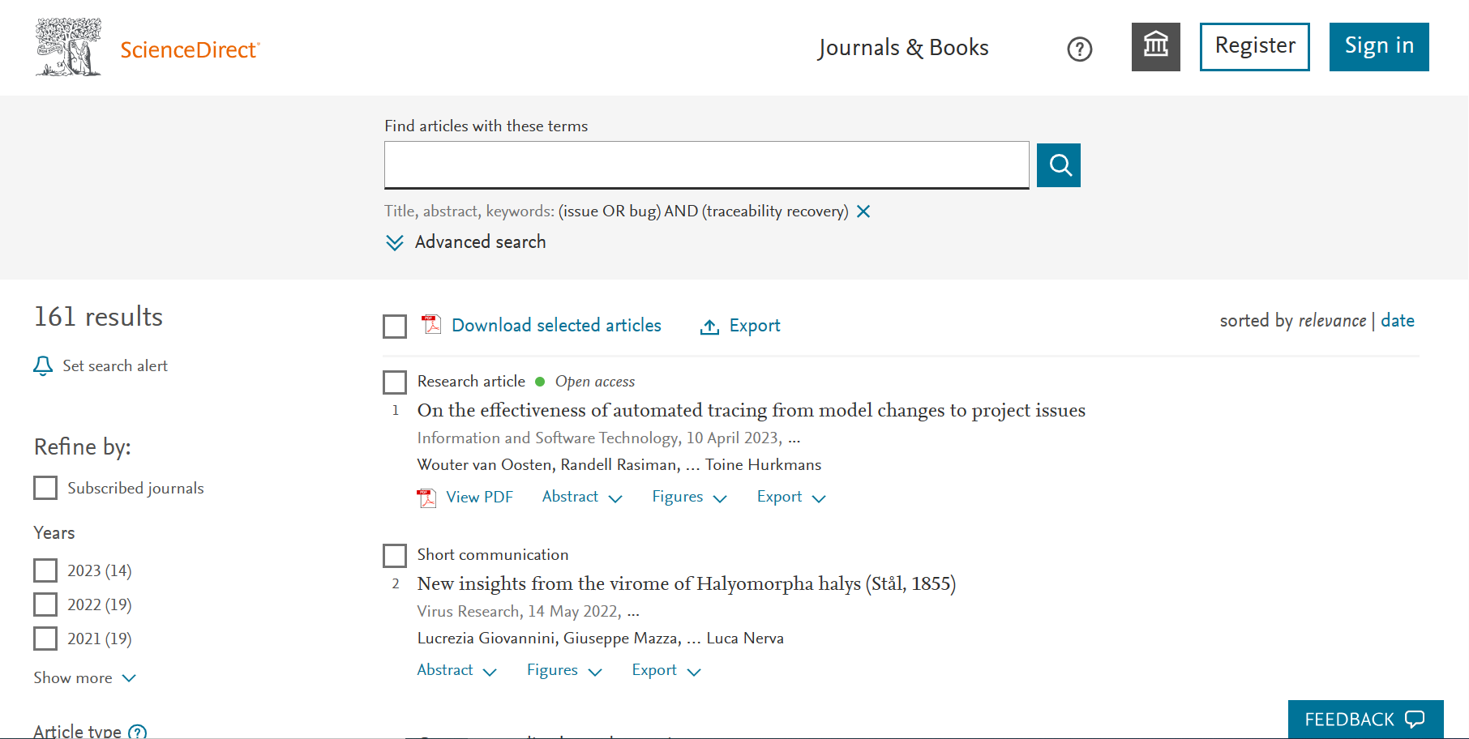
- Advanced search((I1 OR I2) AND (P2)):
(issue OR bug) AND (traceability maintenance)
Screenshot of search process in Scienct Direct:
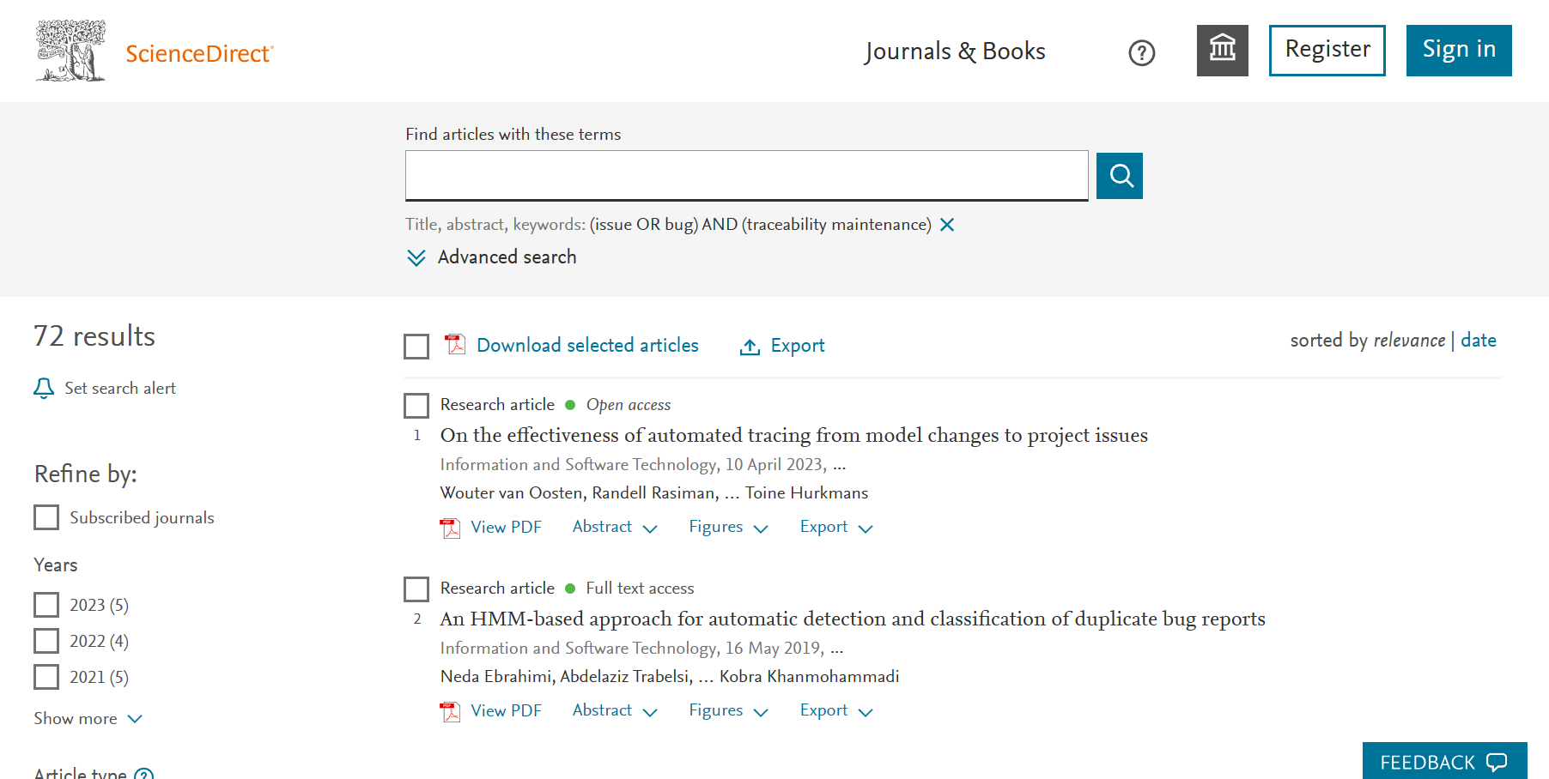
- Advanced search((I1 OR I2) AND (P3)):
(issue OR bug) AND (traceability assessment)
Screenshot of search process in Scienct Direct:
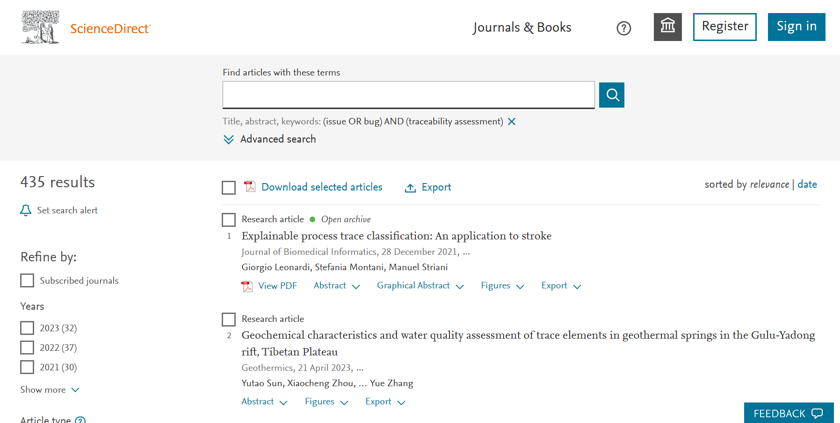
- Advanced search((I1 OR I2) AND (P4)):
(issue OR bug) AND (requirements traceability)
Screenshot of search process in Scienct Direct:
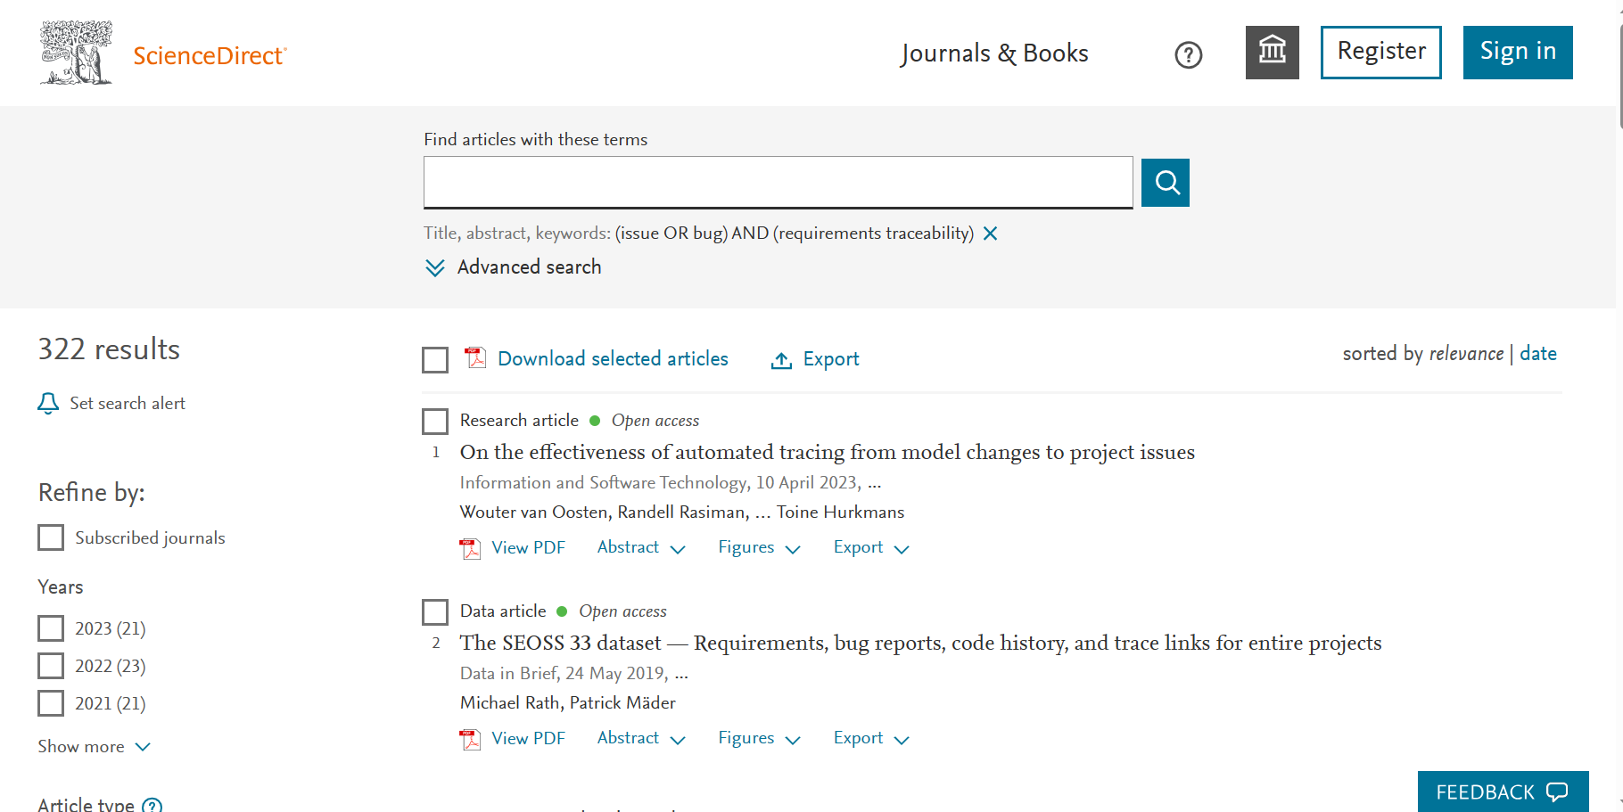
- Advanced search((I1 OR I2) AND (P5)):
(issue OR bug) AND (requirements trace)
Screenshot of search process in Scienct Direct:
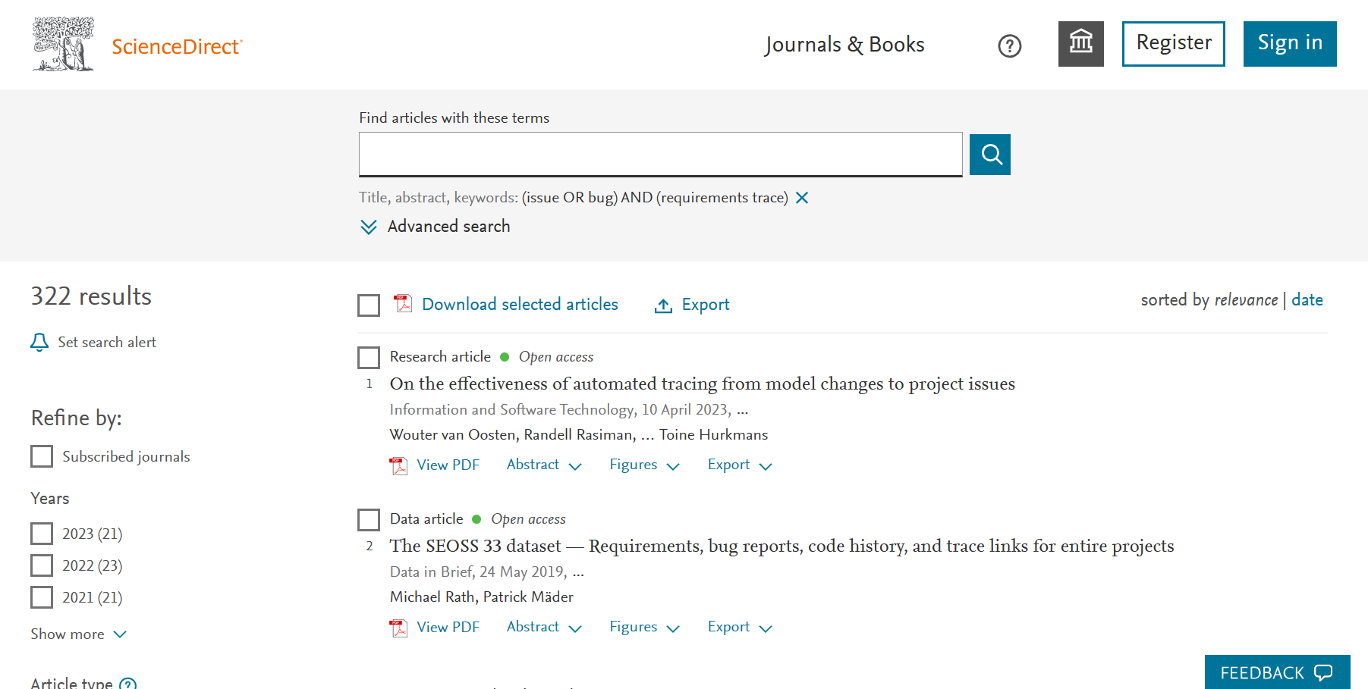
- Advanced search((I1 OR I2) AND (P6)):
(issue OR bug) AND (requirements tracing)
Screenshot of search process in Scienct Direct:
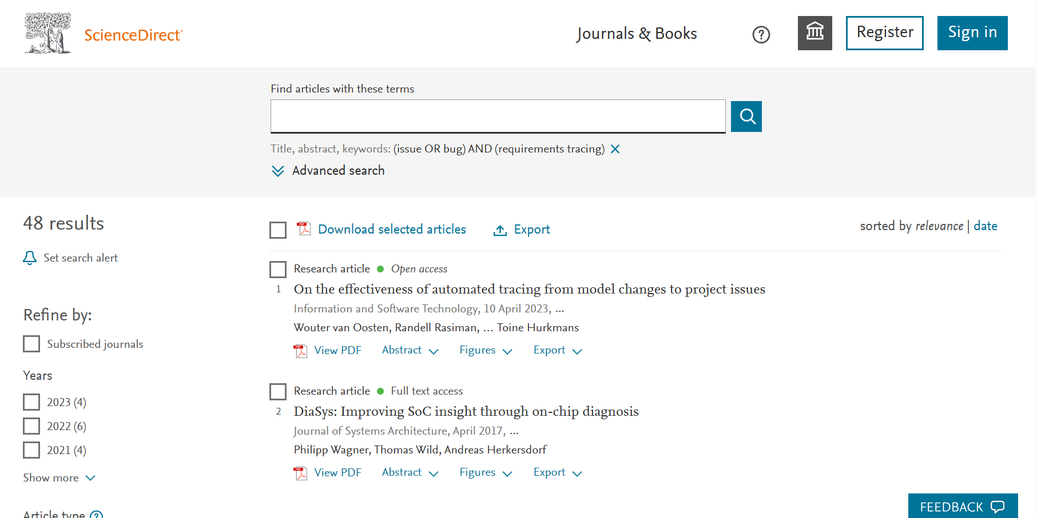
- Advanced search((I1 OR I2) AND (P7)):
(issue OR bug) AND (software traceability)
Screenshot of search process in Scienct Direct:
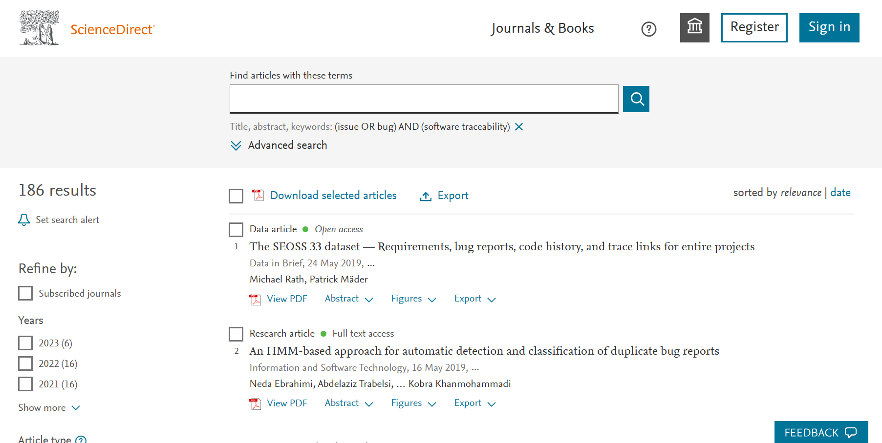
- Advanced search((I1 OR I2) AND (P8)):
(issue OR bug) AND (software trace)
Screenshot of search process in Scienct Direct:
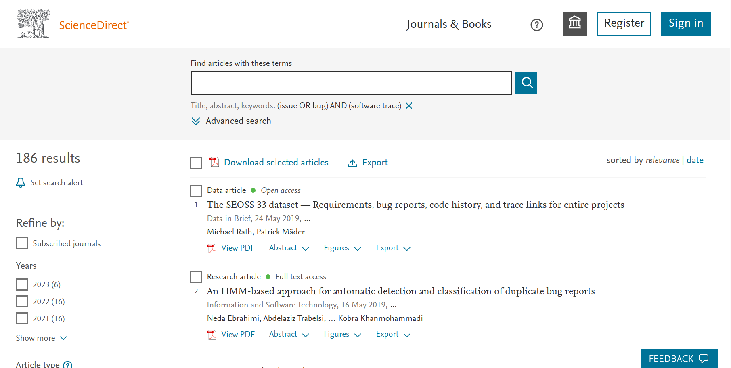
- Advanced search((I1 OR I2) AND (P9)):
(issue OR bug) AND (software tracing)
Screenshot of search process in Scienct Direct:
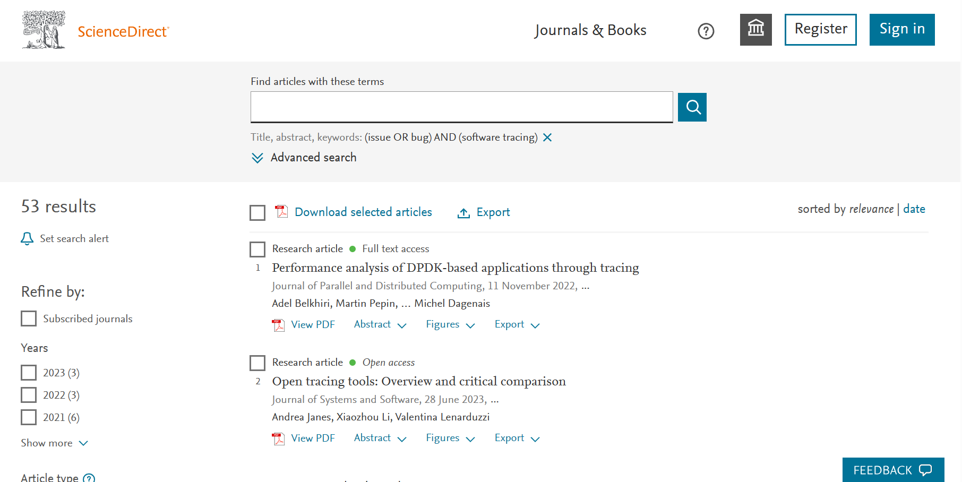
- EI
 | Subject/Title/Abstract
(I1 OR I2)  AND  (P1 OR P2 OR P3 OR P4 OR P5 OR P6 OR P7 OR P8 OR P9) | 60
Expert search:
("issue" OR "bug") AND ("traceability recovery" OR "traceability maintenance" OR "traceability assessment" OR "requirements traceability" OR "requirements trace" OR "requirements tracing" OR "software traceability" OR "software trace" OR "software tracing")
Screenshot of search process in EI:
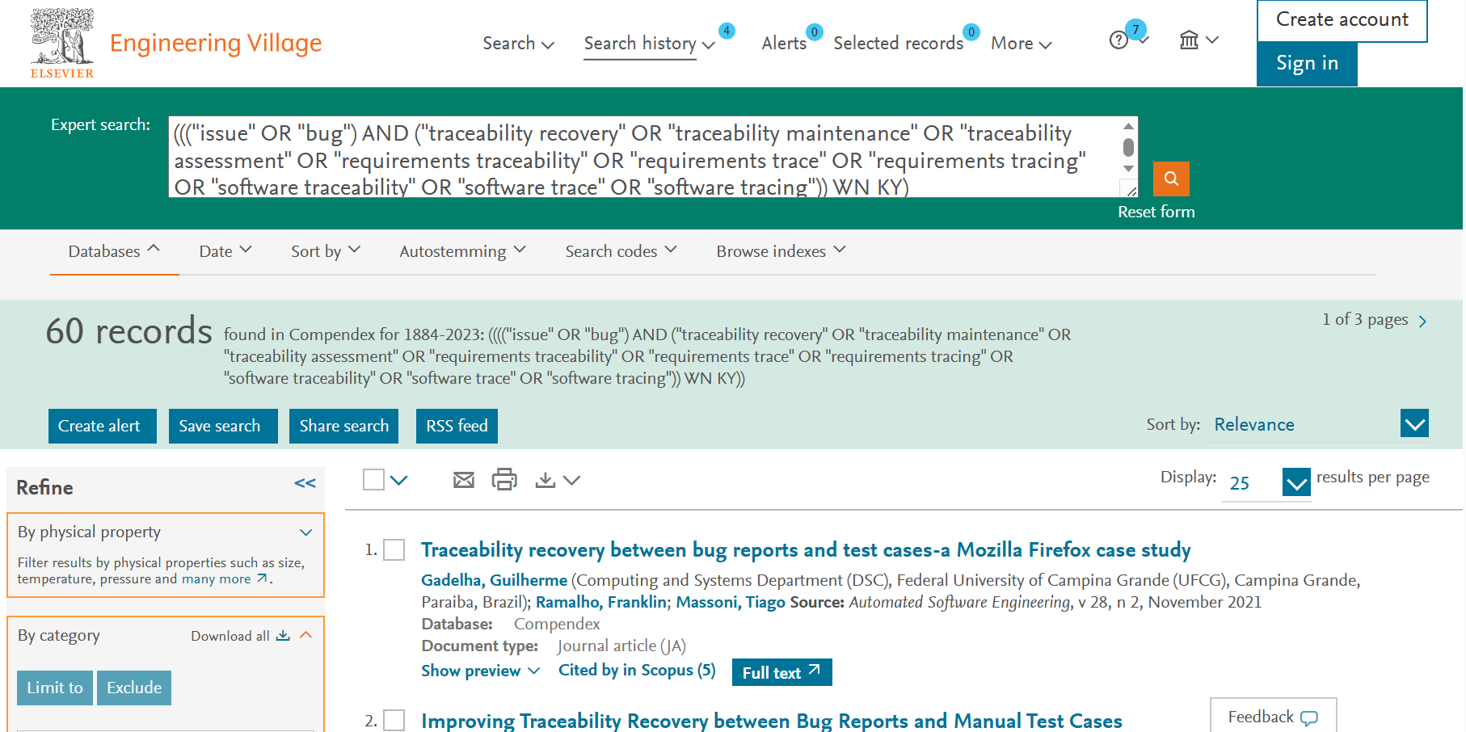
- IEEE
 | Title | Abstract | Index terms
(I1 OR I2) AND (P1 OR P2 OR P3 OR P4 OR P5 OR P6 OR P7 OR P8 OR P9 OR P10) | 8 | 1020 | 291
Total | 1319
- Command Search(Title):
("Document Title":issue OR "Document Title":bug) AND ("Document Title":traceability recovery OR "Document Title":traceability maintenance OR "Document Title":traceability assessment OR "Document Title":requirements traceability OR "Document Title":requirements trace OR "Document Title":requirements tracing OR "Document Title":software traceability OR "Document Title":software trace OR "Document Title":software tracing)
Screenshot of search process in IEEE:

- Command Search(Abstract):
("Abstract":issue OR "Abstract":bug) AND ("Abstract":traceability recovery OR "Abstract":traceability maintenance OR "Abstract":traceability assessment OR "Abstract":requirements traceability OR "Abstract":requirements trace OR "Abstract":requirements tracing OR "Abstract":software traceability OR "Abstract":software trace OR "Abstract":software tracing)
Screenshot of search process in IEEE:
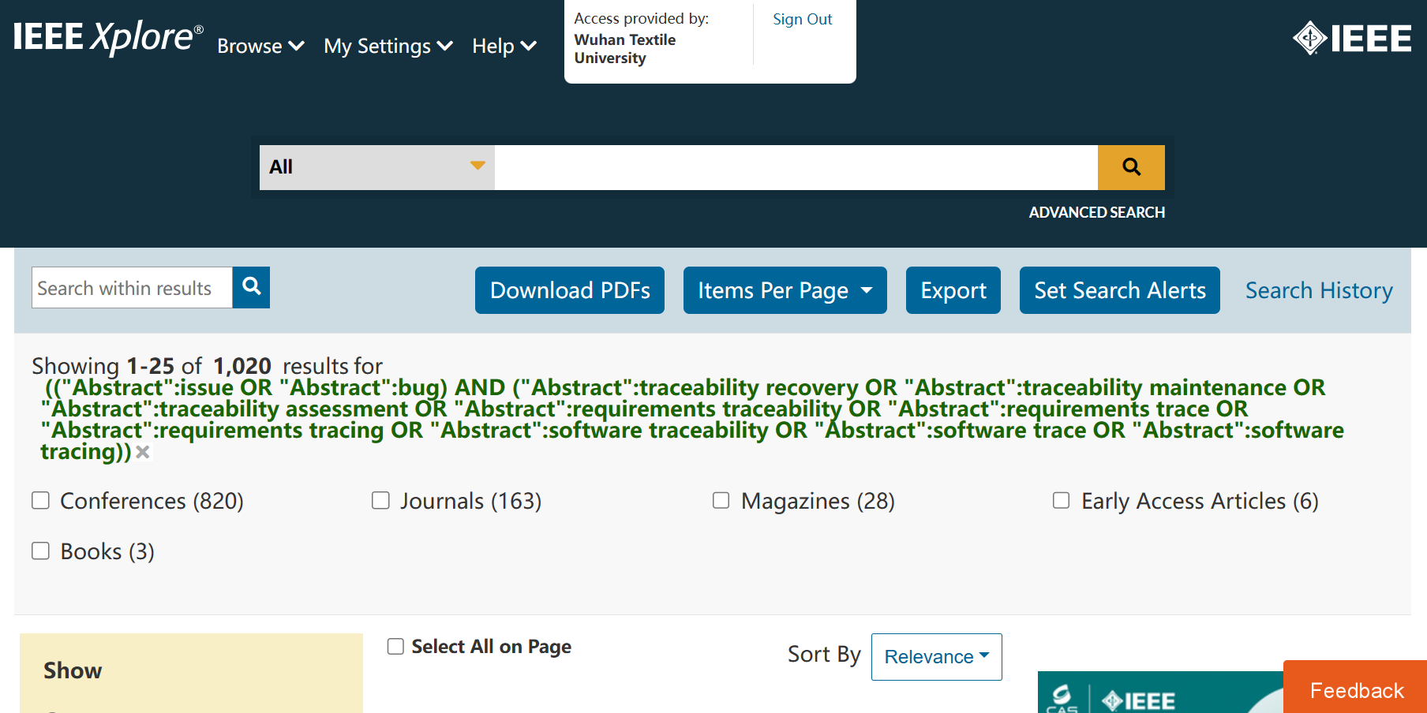
- Command Search(Index Terms):
("Index Terms":issue OR "Index Terms":bug) AND ("Index Terms":traceability recovery OR "Index Terms":traceability maintenance OR "Index Terms":traceability assessment OR "Index Terms":requirements traceability OR "Index Terms":requirements trace OR "Index Terms":requirements tracing OR "Index Terms":software traceability OR "Index Terms":software trace OR "Index Terms":software tracing)
Screenshot of search process in IEEE:
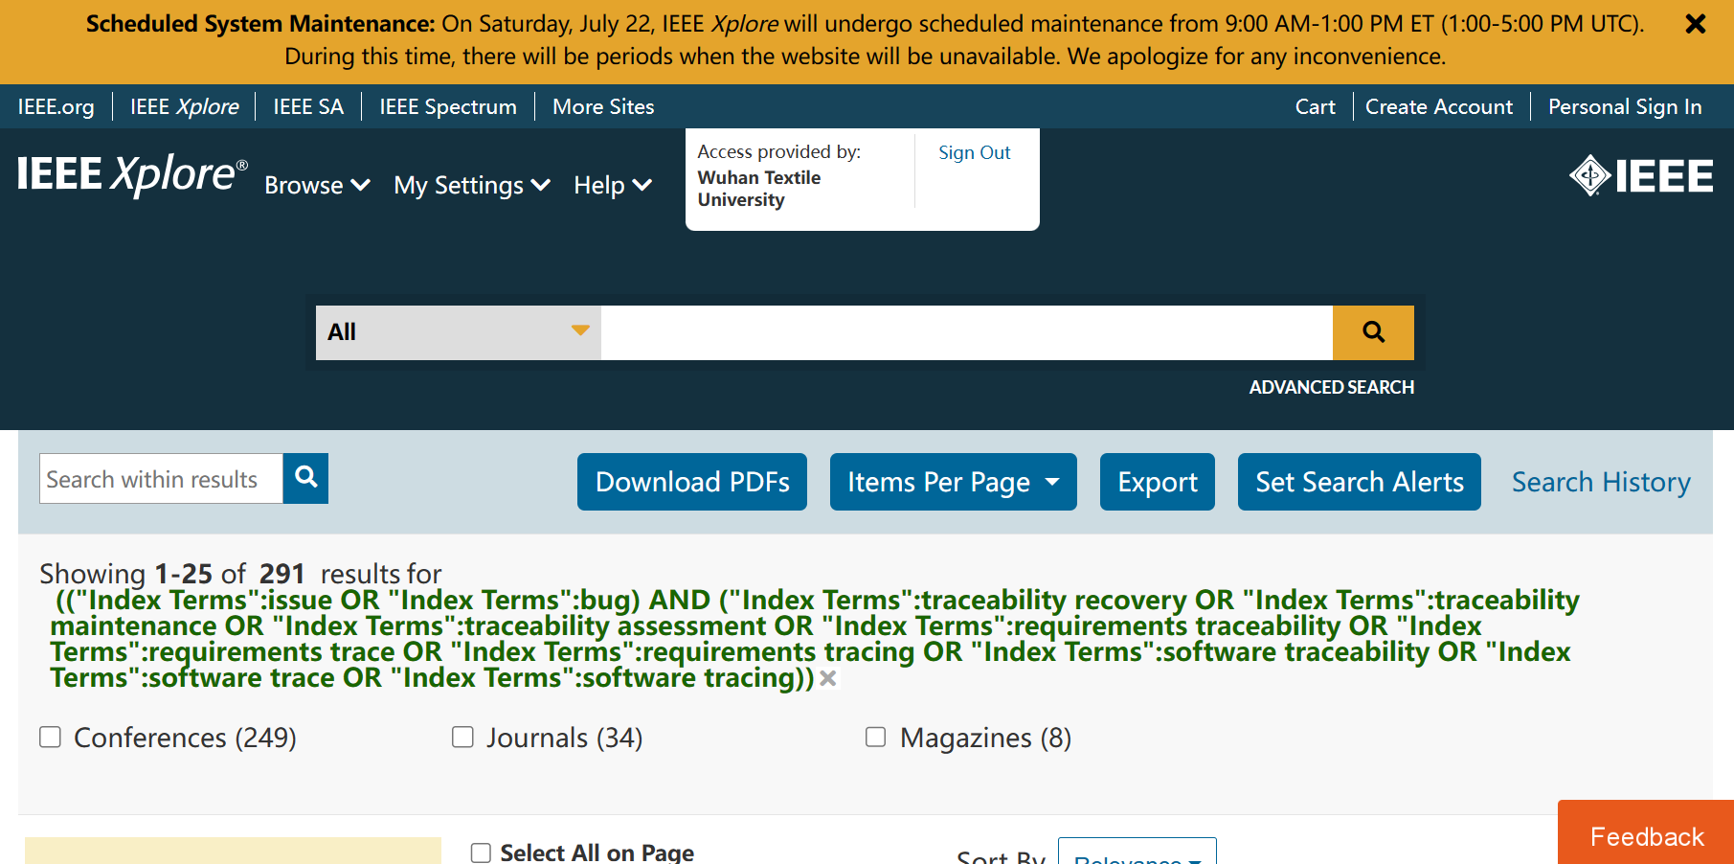
- Web of Science
 | Topic(Searches title, abstract, author keywords, and Keywords Plus.)
(I1 OR I2) AND (P1 OR P2 OR P3 OR P4 OR P5 OR P6 OR P7 OR P8 OR P9 OR P10) | 1159

Advanced Search(Topic):
(issue OR bug) AND (traceability recovery OR traceability maintenance OR traceability assessment OR requirements traceability OR requirements trace OR requirements tracing OR software traceability OR software trace OR software tracing)
Screenshot of search process in IEEE:
